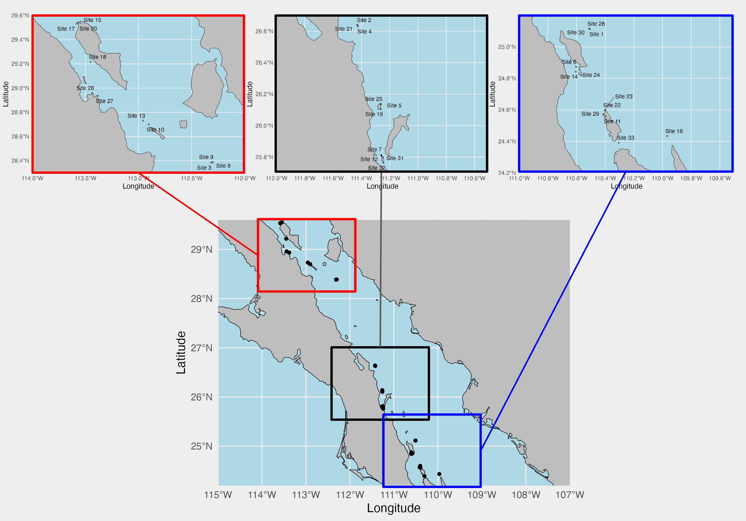

Figure 1: Map of sampling sites in the Gulf of California. The bottom map shows all sites. The top three maps are subsets of three latitude groupings: northern sites (red), middle sites (black), and southern sites (blue).

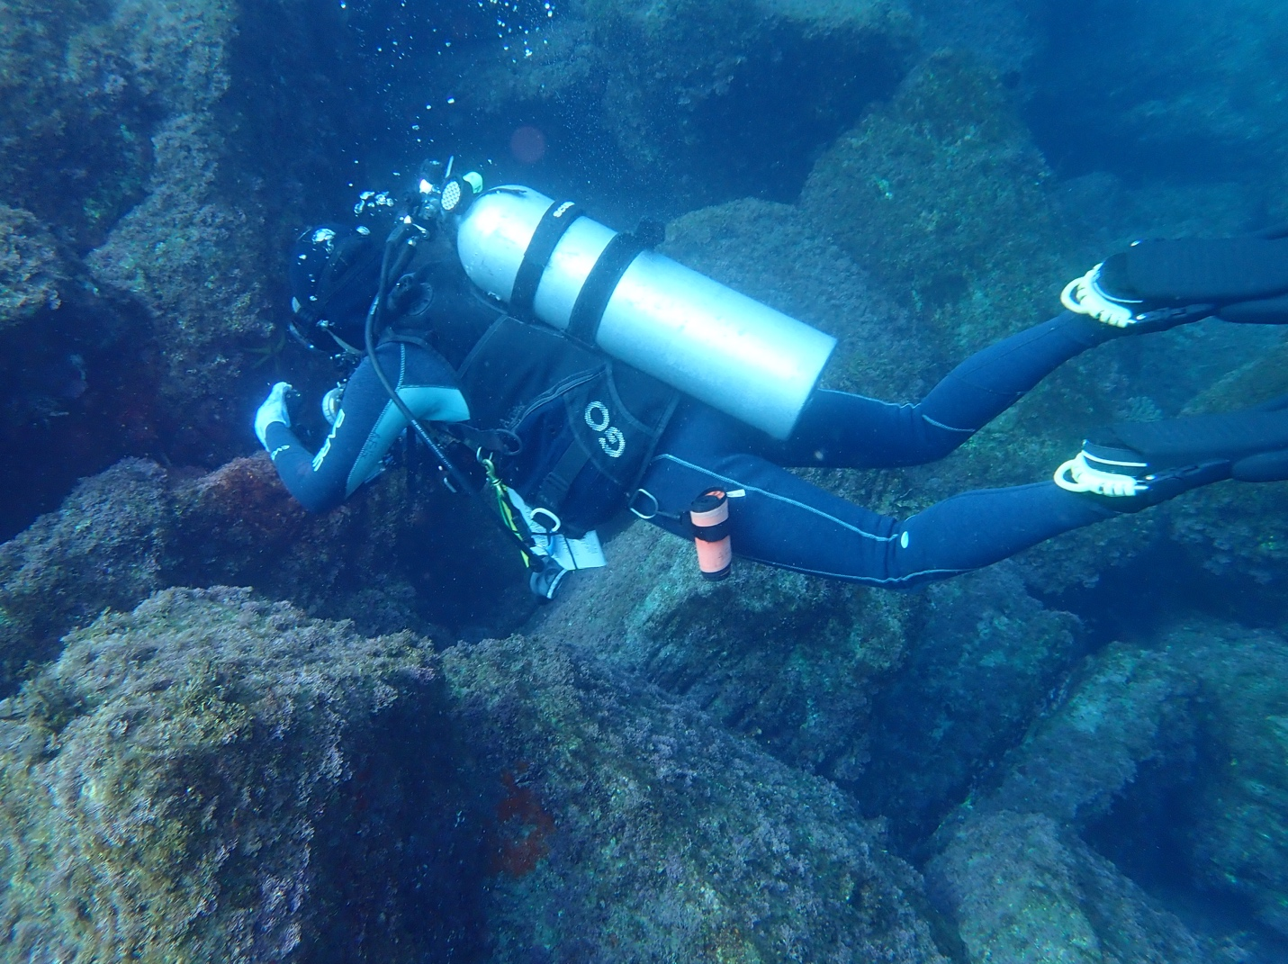

Figure 2. Photo showing a PEDS attached to a citizen science diver’s first stage regulator. The PEDS consists of a black honeycomb plastic puck with a white filter inside.



Figure 3. Venn diagrams showing species overlap (top) and family overlap (bottom) between PEDS and RVS for a) original PEDS species and b) updated PEDS species. Green corresponds to PEDS and purple to RVS.



Figure 3. Diagram of stages of adding fish sequences to our reference database (left blue boxes) and resultant total PEDS species (right white boxes).



Figure 4. Alpha diversity plots for PEDS using Simpson’s diversity index for five metadata variables: latitude group (a), most common habitat (b), maximum dive depth (c), diver (d), and bottom time (e).



Figure 5. Alpha diversity plots for RVS using Simpson’s diversity index for five metadata variables: latitude group (a), most common habitat (b), maximum dive depth (c), diver (d), and bottom time (e).



Figure 6. NMDS beta diversity plots for PEDS following Hellinger transformation of data for latitude group (a), most common habitat (b), maximum depth (c), diver (d), and bottom time (e).



Figure 7. NMDS beta diversity plots for RVS using Gower dissimilarity index for latitude group (a), most common habitat (b), maximum depth (c), diver (d), and bottom time (e).



Figure 8. Family-level composition in each site for PEDS (a) and RVS (b) for 9 families observed in both data sets. The horizontal black lines in each bar in the PEDS plot represents a species within the family.



Figure 9. Map of sampling sites in which each point is colored by similarity, or the number of species in each site for which PEDS and RVS had matching presence / absence data. Each similarity score represents the number of common species present in both or absent in both methods for a given site. a) shows all sites, b) is North, c) is Middle, and d) is South sites.



Figure 10. Scatter plot with a linear regression between species overlap numbers and latitude. Slope is 0.025, R2 value is 0.21, and p-value of the regression is 0.007.